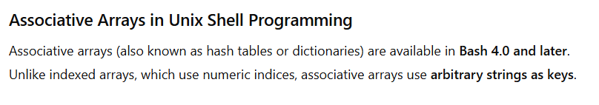

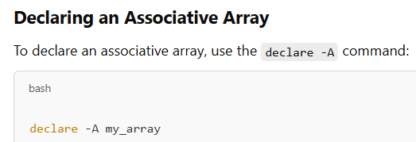

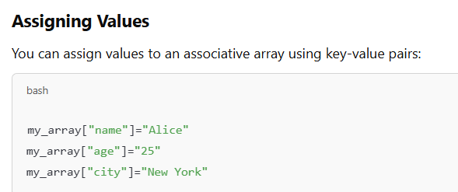

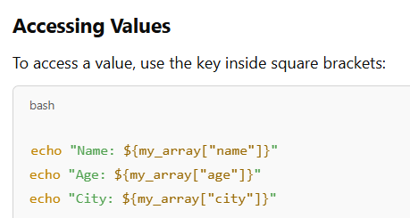

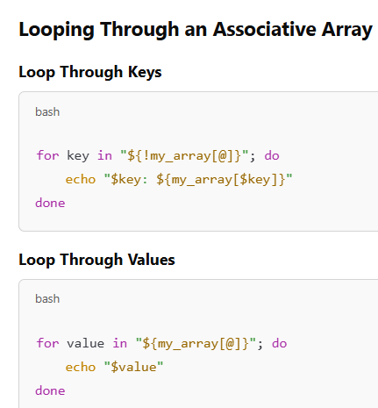

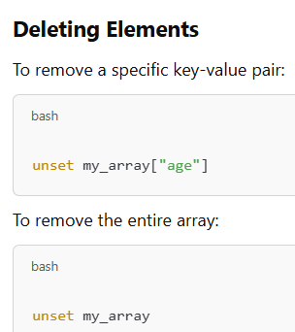

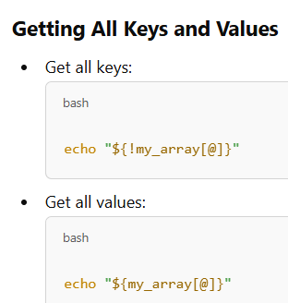

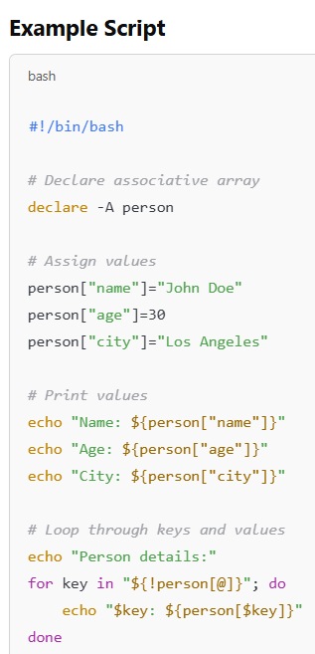

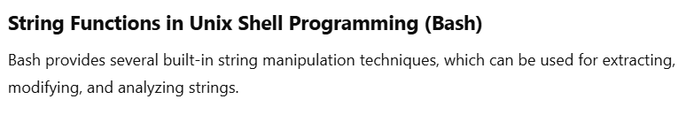

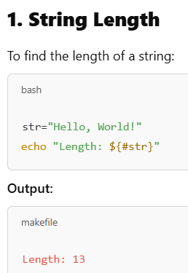

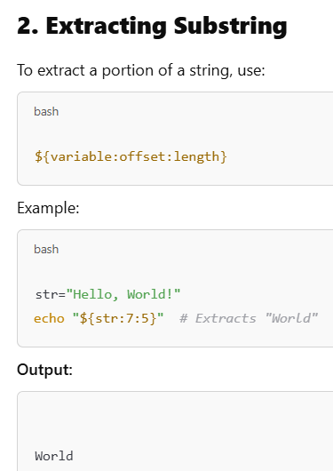

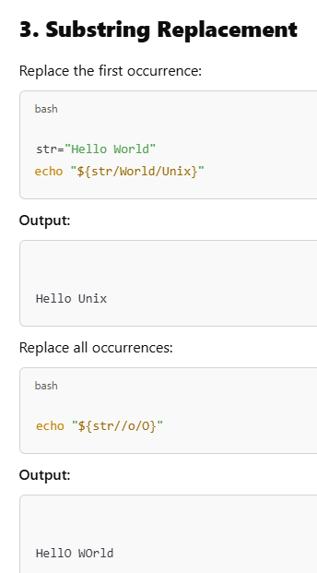

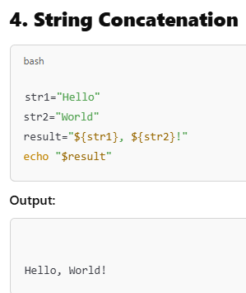

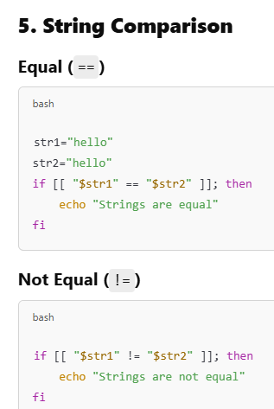

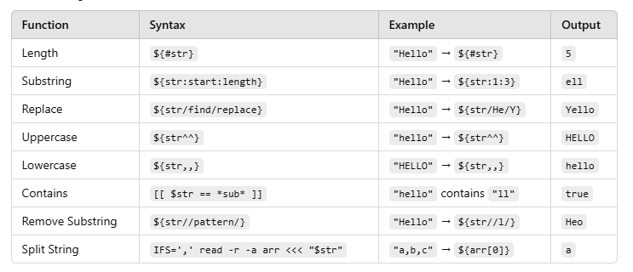

In Unix shell programming, you can perform mathematical operations using the expr command for basic calculations, or the more modern method of arithmetic expansion with the syntax $(( expression )) which allows for direct calculations within the shell script, including addition, subtraction, multiplication, division, and more complex operations like exponentiation.

**Key points about mathematical functions in Unix shell:**

* expr command:
  + Used for simple arithmetic operations like addition, subtraction, multiplication, and division.
  + Syntax: expr operand1 operator operand2
  + Requires escaping special characters like the multiplication symbol (\*)
  + Considered less efficient than arithmetic expansion due to forking a new process
* Arithmetic expansion ($(( ))):
  + Preferred method for most calculations in modern shells like Bash
  + Allows direct calculation within the shell script without needing a separate command
  + Syntax: $(( expression ))

Example usage:

Addition with expr.

|  |
| --- |
| result=`expr 5 + 3`  echo $result # Outputs: 8 |

Multiplication with arithmetic expansion.

|  |
| --- |
| total=$(( 10 * 2 ))  echo $total # Outputs: 20 |

